Madlib Program-A-Thon
Welcome to the Boulder Web Developer inaugural meetup and the Madlib Program-A-Thon! Just a few quick things about the competition and then we’ve outlined some of the key functionality/libraries you should know.
Rules:
- You need to include a madlib from: http://dev.markitondemand.com/Meetup/MadLib/GetMadLibJS
- Your page should require no interaction from the judges, they will simply open the htm file and your page should handle everything else.
That’s pretty much it. Your mission is to take that chuck of Javascript and make the coolest webpage anyone has ever seen!
Setup:
- Fork from the GitHub repo located here: https://github.com/markitondemand/Meetup
  - Have questions on GitHub see below, or ask us for help
- Check out index.htm, this is where the magic happens
  - We have two approaches to get you started see more details below
- Once you have made your changes make sure to commit back to your fork, this is where we will look during the judging
Libraries:
jQuery - is required as some of the other libraries rely on it, should you have a different favorite javascript library feel to also include it, and see the section about jQuery.noConflict(); if you don’t want jQuery mucking up the ‘$’ variable
MadLibEngine.js – this is a required file as it helps wrap up the basic functionality you can use to parse and work with your madlib, how you use it is up to you. The file is heavily commented however we will also include a breakdown of the methods in this doc
Utils.js – this file is setup to help with adding APIs into your project and wrap up some of the hooks provided in the MadLibEngine.js, again you will find many comments in the file and a breakdown of the methods in this doc

Starting Points:
Option1 -
<!-- SIMPLE OPTION: UNCOMMENT THIS SECTION TO USE THE STANDARD MADLIB
<script src="http://dev.markitqa.com/Meetup/MadLib/GetMadLibJS"></script>
<script src="http://dev.markitqa.com/Meetup/MadLib/GetMadLibWordsJS"></script>

This is a great approach if you don’t want to deal with JSONP callbacks, with this approach the words and html (for the madlib) are added onto the page at page load. Like the comment says just uncomment this block (make sure to comment out the other block) and you are ready to run!

Option2 –
<!-- FUN/API OPTION: UNCOMMENT THIS SECTION TO USE APIS -->
<script src="Content/js/Util.js"></script>
<script>

This is the default approach, in the example you will see the Utils class wrap up the JSONP calls to get the words and the html, then in HandleWordPreFill you can see how the API calls work. We have outlined a couple of fun ones to get you started.

Data Structures:

Madlibs –
Returned from http://dev.markitondemand.com/Meetup/MadLib/GetMadLibJS as a string of html and stored in “madLibEngine.templateHTML”
The basic structure will look like this:
<div class="madLib">
<div class="title">My Madlib</div>
<span class=”sentence”> This is <span data-ML="noun_person"></span>’s favorite</span>
</div>
- where data-ML will designate the word that needs to be filled in to complete the mad lib.

Word Collection –
Returned from http://dev.markitondemand.com/Meetup/MadLib/GetMadLibWordsJS as a JSON object stored in “madLibEngine. wordCollection”
The basic structure is:
{wordCategory1: [word1, word2, word3], wordCategory2: [word1, word2]}
The way the engine is setup is that when it parses the template it will find data-ML=wordCategory1 and use the first word in the array, and the next time it finds data-ML=wordCategory1 it will use the next word. This process will complete until it hits the end of the array at which point it will start over
MadLibEngine.js

setupWordCollection(oArgs) – this function sets up the word collection used for parsing the template. It will use the words in wordCollection or alternatively you could pass oArgs.data equal to a json object that adheres to structure outlined above, for an up-to-date list of the different word categories

getTemplateFragment() – returns a DOM fragment of the madlib template – unparsed

addTemplateToPage() – takes the madlib template appends it to <div id=”madLibContent”> - unparsed, then returns the template as a DOM element

addAndFillTemplate() – takes the madlib template appends it to <div id=”madLibContent”>, then parses the template using parseHTML and fills the word entries using fillNextWord, returns the template as a DOM element

parseHTML(element) – takes the madlib template as the ‘element’ finds all the <span data-ML=””> elements a creates an array that fillNextWord will populate, returns the same element that was passed in

fillNextWord() – no inputs/return, walks through the elements as created in paresHTML and fills in the word corresponding to the category. This function will call preFillHandler before filling the word, and will call postFillHandler at the end of function call.

preFillHandler(element, currentWord, wordCategory) – element is a DOM element of the span element needing a word, currnetWord a string containing the current word to be filled in, category a string as indicated by the element. This function should return true if the current word should be used in the element. This method is basically empty and meant to be overridden if you would like hook on the behavior on how the template fills

postFillHandler(element) – element is a DOM element of the span element that was just potentially filled (see preFillHandler). By default this function only calls fillNextWord, again meant to be overridden to extract control over the template fill

Utils.js
GitHub Quickstart Guide:

Your first step will be to install Git on your machine, the best/easiest tutorial can be found here: http://help.github.com/win-set-up-git/

Once you are setup, you’ll need to fork the repo located at https://github.com/markitondemand/Meetup

There is a guide here: http://help.github.com/fork-a-repo/ however if you’re not a fan of command line you can do this pretty quick and easy with GUIs.

From the repo located above click the fork button:
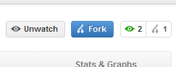
This will kick off the process; once it’s complete you will see the same files in your account. At this point launch the git gui:
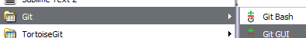

From there click “Clone Existing Repository”

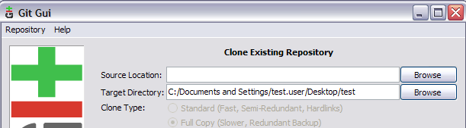

The target directory is where you want the files on your computer for the source you should grab that from GitHub, in your account looking at the forked repo select this field:

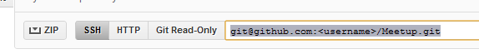

Once you have edited the files you’ll need to push them back into your repo before the judging can begin. From the Git GUI select “Rescan” to see your changes and then “Stage Changes”

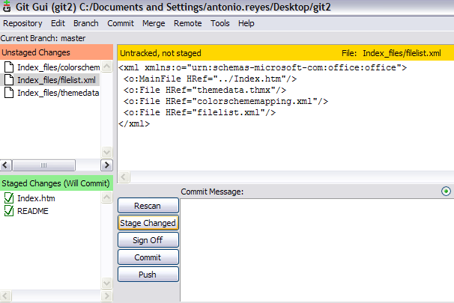

Then commit your changes, this creates record of the change in your local repository, and then finally you will need to “Push” the changes

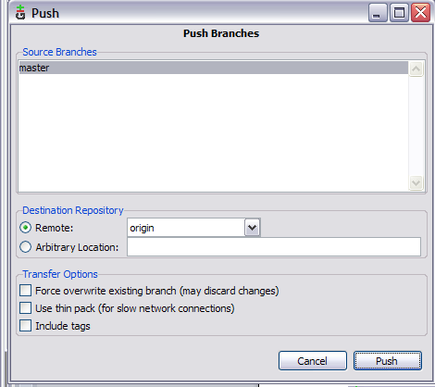

This will move your changes back onto github. Congratulations your done!

